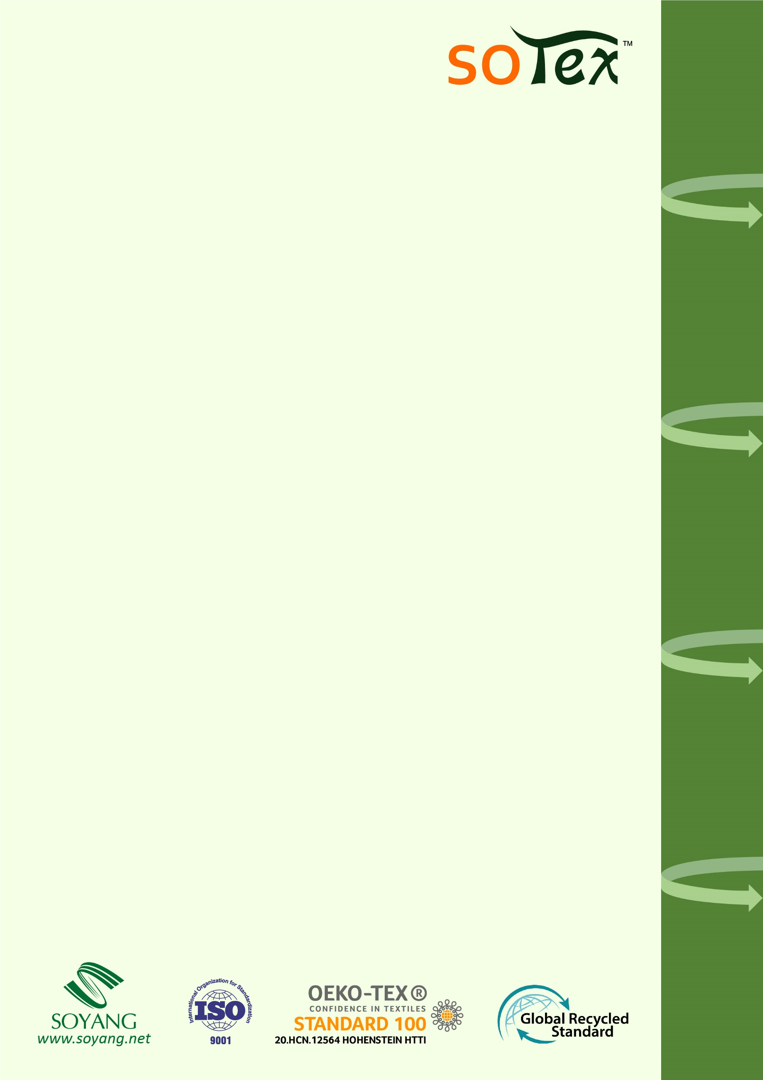

**Nightstar BlackRock**

Soyang's comprehensive range: PVC-Free. Supported by full industry chain. Compatible with various printing methods.

**ST-226T/ST-226D**

- 100% warp-knitted polyester fabric with W/B structure

- Full opacity, widely used as frame, backdrops, pop-up,etc

- Light weight, convenient for transportation and installation

**BRIEF DESCRIPTION**

|  |  |  |  |
| --- | --- | --- | --- |
| **PROPERTIES** | **TEST METHOD** | **METRIC** | **IMPERIAL** |
| Total Weight | DIN EN ISO 2286-2, ASTM D751 | 250 g/sq.m | 7.4 oz/sq.yd |
| Base Fabric | DIN 60001, ASTM D7641 | 100% polyester | |
| Weave Method | N/A | Warp-knitted | |
| Shrinkage | ISO 9866-2-1991 | ≤3% | |
| Shielding Rate | ANSI PH2.19, ISO 5/2 | 100% | |
| Flame Resistance | EN13501-1, DIN 4102-1-B1,  NFPA 701 Test1 | EN13501-1, DIN 4102-1-B1,  NFPA 701 Test1 | |
| Recommend Fixation  Temperature | N/A | 190℃-200℃, 30s-50s | |
| Width Available | DIN EN ISO 3759, ASTM D751-2006 | Max 500cm | 197" |
| Standard Length | DIN EN ISO 3759, ASTM D751-2006 | 50m | 55yds |
| NOTE: It is normal that the weight of most products will have an average fluctuation of 5%. All above information shall only used as a guide; buyers shall independently test and determine the products suitability. The mentioned data are average of test result and should not be used for the purpose of lawsuit or warranty. | | | |

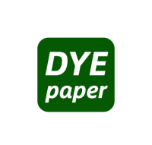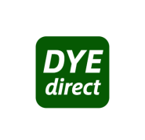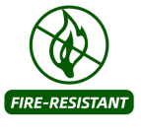

**MATERIAL DETAILS**

**INK PRINTABILITY**

**FEATURES**